- Introductory concepts of DBMS

- What are the disadvantages of File processing?

Data redundancy and inconsistency
Multiple file formats, duplication of information in different files

Difficulty in accessing data
Need to write a new program to carry out each new task

Data isolation
Multiple files and formats

Integrity problems
Integrity constraints (e.g., account balance > 0) become “buried” in
program code rather than being stated explicitly
Hard to add new constraints or change existing ones

Atomicity of updates
es may leave database in an inconsistent state with partial updates
carried out
Example: Transfer of funds from one account to another should either
complete or not happen at all

Concurrent access by multiple users

Concurrent access needed for performance
Uncontrolled concurrent accesses can lead to inconsistencies
Example: Two people reading a balance (say 100) and updating it by
withdrawing money (say 50 each) at the same time

Security problems

Hard to provide user access to some, but not all, data

Advantages of Database Management System (DBMS)
1. Improved data sharing
2. Improved data security
3. Better data integration
4. Minimized data inconsistency
5. Improved data access
6. Improved decision making
7. Increased end-user productivity

Disadvantages of Database Management System (DBMS):
1. Increased costs
2. Management complexity
3. Maintaining currency
4. Frequent upgrade/replacement cycles

Levels of Abstraction

Physical level: describes how a record (e.g., instructor) is stored.

Logical level: describes data stored in database, and the relationships among
the data.
type instructor = record
ID : string;
name : string;
dept_name : string;
salary : integer;
end;

View level: application programs hide details of data types. Views can also
hide information (such as an employee’s salary) for security purposes.

View of Data
An architecture for a database system

Types of Data Base

1) Classification Based on the number of user
Single user
Multiple work group DB
2) Classification Based on location
Centralized DB
Distributed DB

3) Classification Based on how they use
Operation DB
Transaction DB

4) Degree to which Data are structured
Unstructured data
Semi-structure Data
Structure Data

5) DB System User
Naive user
End User
System Analyst & Application Programmer
DBA

List and explain the applications of DBMS.
Railway Reservation System
Library Management System
Banking
Credit card transactions
Universities and colleges
Social Media Site
Online Shopping
Finance
Manufacturing
Airline Reservation system

Describe functions of DBA to handle DBMS.
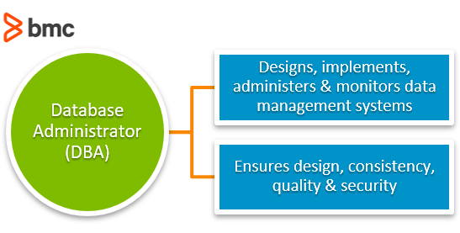
DBA stands for 'Database Administrator' their ate some functions of DBA that is-
1.Conceptual Architecture Schema.
2.Authorization and Integrity Schema.
3.Granting of User Access.
4.Backup and Recovery Mechanisms.
5.Monitering Performance.
6.Physical Database Design.

Disadvantages of Relational Model in DBMS
The different disadvantages of Relational model are as follows:
1. Substantial hardware and system software overhead
2. Possibility of poor design and implementation
3. Potential “islands of information” problems

The advantages of ER model in DBMS

1. Exceptional conceptual simplicity
2. Visual representation
3. Effective communication tool
4. Integrated with the relational database model

The disadvantages of ER Model in DBMS

1. Limited constraint representation
2. Limited relationship representation
3. No data manipulation language
4. Loss of information content

Explain different types of keys available in Relational Model.

Types of Keys in DBMS

In the Relational Database Model, keys are important because they are used to ensure that each row in a table is uniquely identifiable. They are also used to establish relationships among tables and to ensure the integrity of the data.
Composite key:
A key may be composed of more than one attribute. Such a multi attribute key is known as a composite key.
Relational Database Keys:
Super key: An attribute (or a combination of attributes) that uniquely identifies each row in a table.
Candidate key: A minimal (irreducible) superkey. A superkey that does not contain a subset of attributes that is itself a superkey.
Primary key: A candidate key selected to uniquely identify all other attribute values in any given row. Cannot contain null entries.
Secondary key: An attribute (or combination of attributes) used strictly for data retrieval purposes.
Foreign key: An attribute (or combination of attributes) in one table whose values must either match the primary key in another table or be null.

Explain Mapping

Mappings
Process of transforming request and results between three level it's called mapping.
There are the two types of mappings:
- Conceptual/Internal Mapping
- External/Conceptual Mapping

1. Conceptual/Internal Mapping:
- The conceptual/internal mapping defines the correspondence between the conceptual view and the store database.
- It relates conceptual schema with internal schema.
- It specifies how conceptual record and fields are represented at the internal level.
- There could be one mapping between conceptual and internal levels.

2. External/Conceptual Mapping:
- The external/conceptual mapping defines the correspondence between a particular external view and conceptual view.
- It relates each external schema with conceptual schema.
- Example: fields can have different data types; fields and record name can be changed; several conceptual fields can be combined into a single external field.
- There could be several mapping between external and conceptual levels.

Data Independence

There are two types of data independence:

1. Logical Data Independence
- The ability to change the conceptual schema without having to change the external schema.
- Logical data independence is used to separate the external level from the conceptual view.
- If we do any changes in the conceptual view of the data, then the user view of the data would not be affected.
- Logical data independence occurs at the user interface level.

2. Physical Data Independence
- The ability to change the change the internal schema without having to change the conceptual schema.
- If we do any changes in the storage size of the database system server, then the Conceptual structure of the database will not be affected.
- Physical data independence is used to separate conceptual levels from the internal levels.
- Physical data independence occurs at the logical interface level.
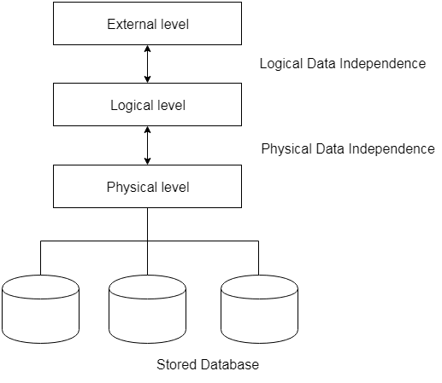

DBMS Architecture
- The DBMS design depends upon its architecture.
- The basic client/server architecture is used to deal with a large number of PCs, web servers, database servers and other components that are connected with networks.
- The client/server architecture consists of many PCs and a workstation which are connected via the network.
Types of DBMS Architecture
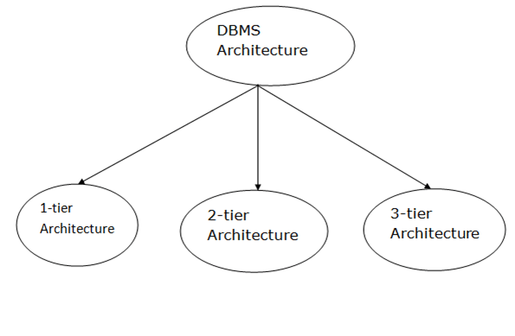

1-Tier Architecture
- In this architecture, the database is directly available to the user.
- It means the user can directly sit on the DBMS and uses it.
- Any changes done here will directly be done on the database itself. It doesn't provide a handy tool for end users.
- The 1-Tier architecture is used for development of the local application, where programmers can directly communicate with the database for the quick response.

2-Tier Architecture
- The 2-Tier architecture is same as basic client-server.
- In the two-tier architecture, applications on the client end can directly communicate with the database at the server side.
- The user interfaces and application programs are run on the client-side.
- The server side is responsible to provide the functionalities like: query processing and transaction management.
- To communicate with the DBMS, client-side application establishes a connection with the server side.
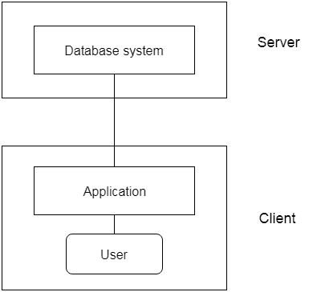
Fig: 2-tier Architecture

3-Tier Architecture
- The 3-Tier architecture contains another layer between the client and server. In this architecture, client can't directly communicate with the server.
- End user has no idea about the existence of the database beyond the application server.
- The database also has no idea about any other user beyond the application.
- The 3-Tier architecture is used in case of large web application.
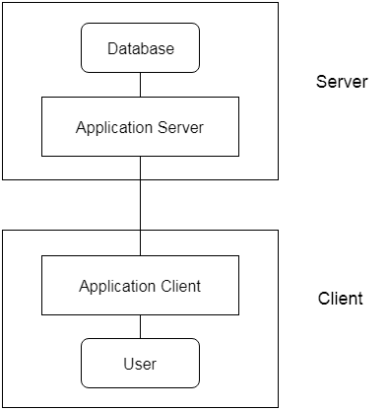
Fig: 3-tier Architecture

Define the terms: Super key, Candidate key, Primary key, Foreign
key, Alternate key and Unique key.

- It is used to uniquely identify any record or row of data from the table. It is also used to establish and identify relationships between tables.
- Primary Key
A primary key is a minimal set of attributes (columns) in a table that uniquely identifies tuples (rows) in that table.

Primary Key rules
- A primary key may have one or more attributes.
- There is only one primary key in the relation (table).
- A primary key attribute value cannot be NULL.
- Super Key
- A Super key is a set of attributes or more in a table that uniquely identifies each records in that table.
- Candidate Key
- A candidate key is a subset of a super key.
- A candidate key is a single attribute or the least combination of attributes that uniquely identifies each record in the table.
- Every candidate key is a super key but every super key is not a candidate key.

- Foreign Key
- A Foreign Key is a database key that is used to link two tables together.
- A foreign key is a column or set of columns in one table whose values must have matching values in the primary key of another (or the same) table.

- Alternate Key
- Alternate keys are those candidate keys which are not the Primary key. There can be only one Primary key for a table.
- Therefore all the remaining Candidate keys are known as Alternate or Secondary keys.

What is E-R diagram?
- E-R diagram: (Entity-Relationship diagram)
- It is graphical (pictorial) representation of database.
- It uses different types of symbols to represent different objects of database.

Enity
- An entity is a person, a place or an object.
- An entity is represented by a rectangle which contains the name of an entity.
- Example: specific person, company, event, plant

Enity Set
- It is a set (group) of entities of same type.
- Example: set of all persons, companies, trees, holidays

Attributes
- Attribute is properties or details about an entity.
- An attribute is represented by an oval containing name of an attribute.
- Attributes of Student are:
- Roll No
- Student Name
- Branch
- Semester

Relationship
- Relationship is an association (connection) between several entities.
- It should be placed between two entities and a line connecting it to an entity.
- A relationship is represented by a diamond containing relationship's name.

Relationship Set
- A relationship set is a set of relationships of same type.

Types of Relationship Sets-
- Unary relationship set
- Binary relationship set
- Ternary relationship set
- N-ary relationship set

1. Unary Relationship Set-

Unary relationship set is a relationship set where only one entity set participates in a relationship set.

Example-
One person is married to only one person

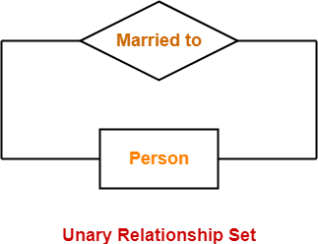

2. Binary Relationship Set-

Binary relationship set is a relationship set where two entity sets participate in a relationship set.

Example-
Student is enrolled in a Course

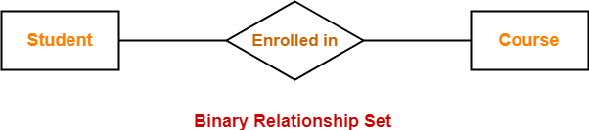

3. Ternary Relationship Set-

Ternary relationship set is a relationship set where three entity sets participate in a relationship set.

Example-

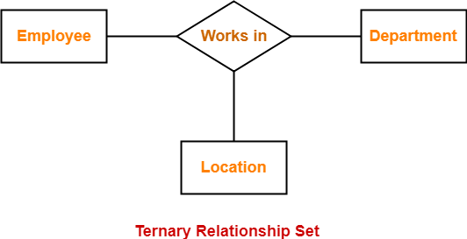

4. N-ary Relationship Set-

N-ary relationship set is a relationship set where ‘n’ entity sets participate in a relationship set.

Types of Attributes

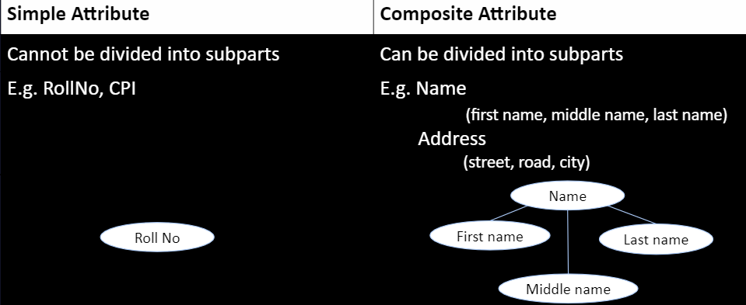

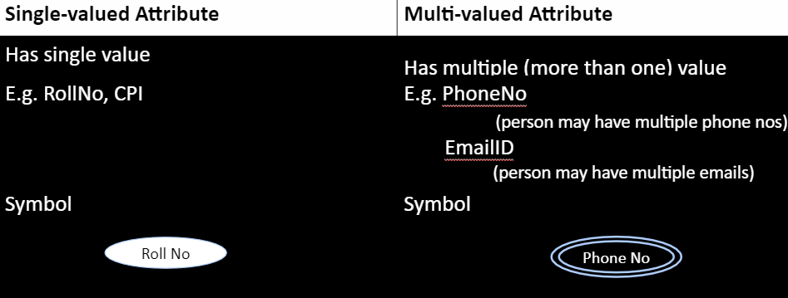

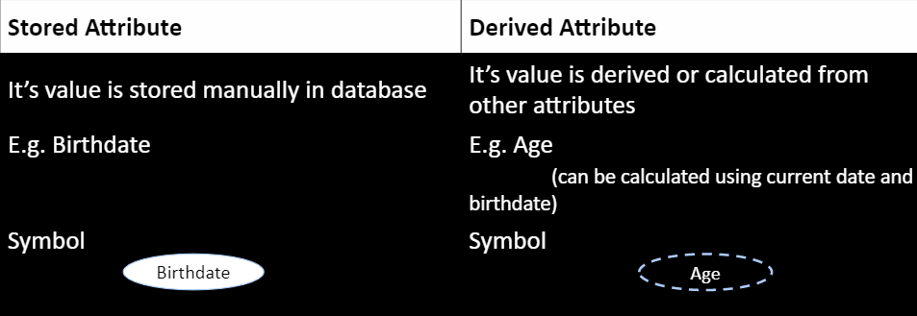

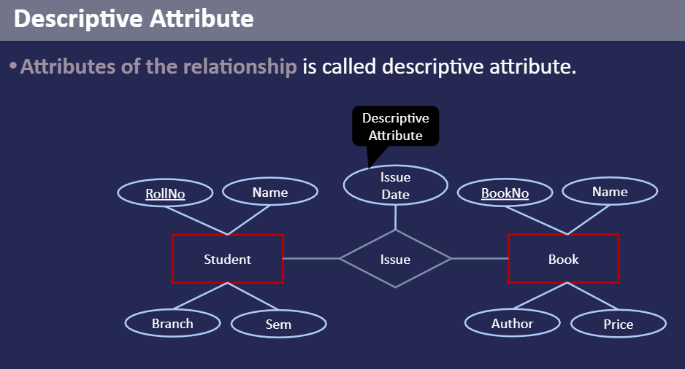

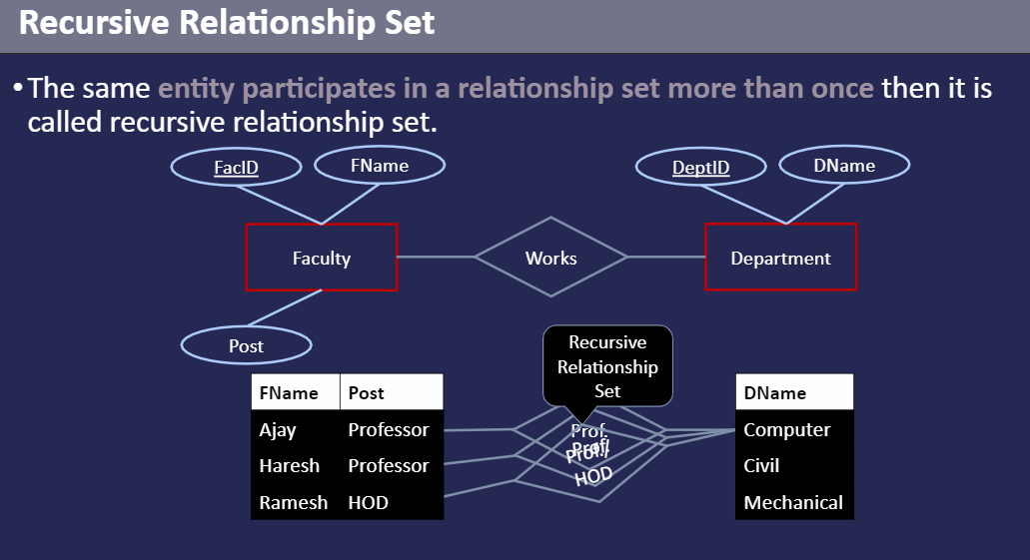

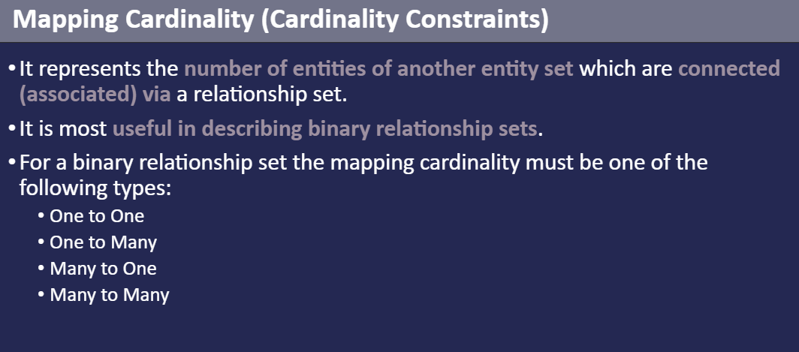

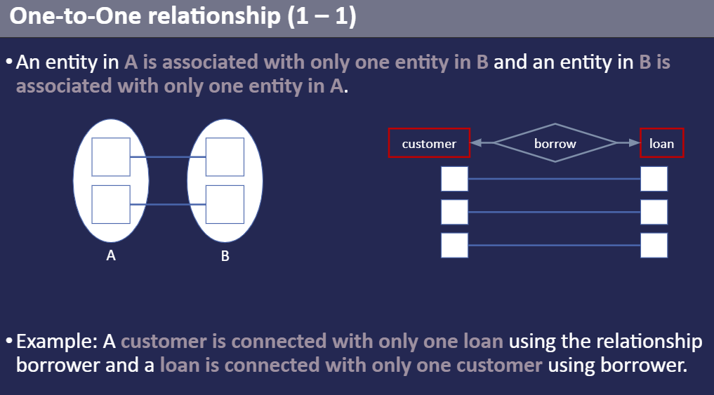

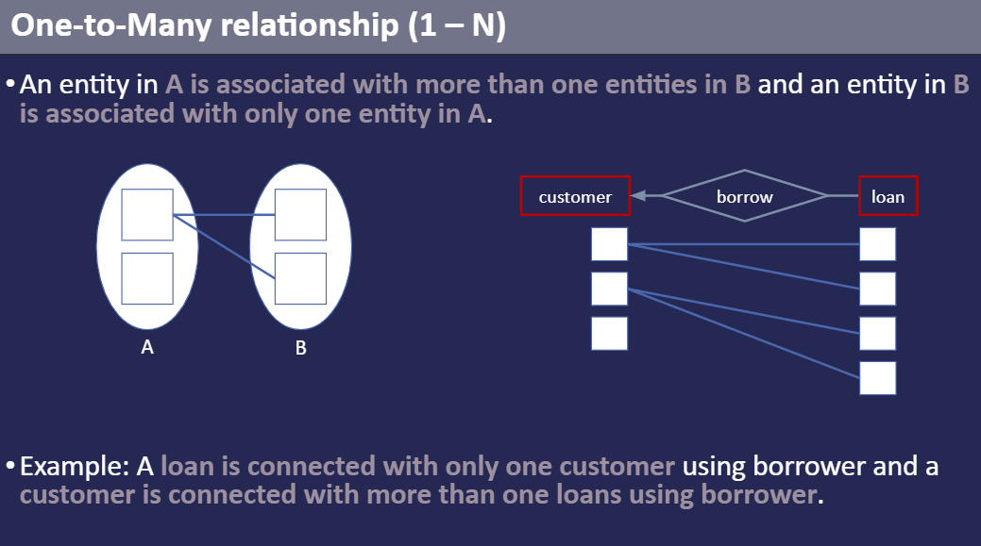

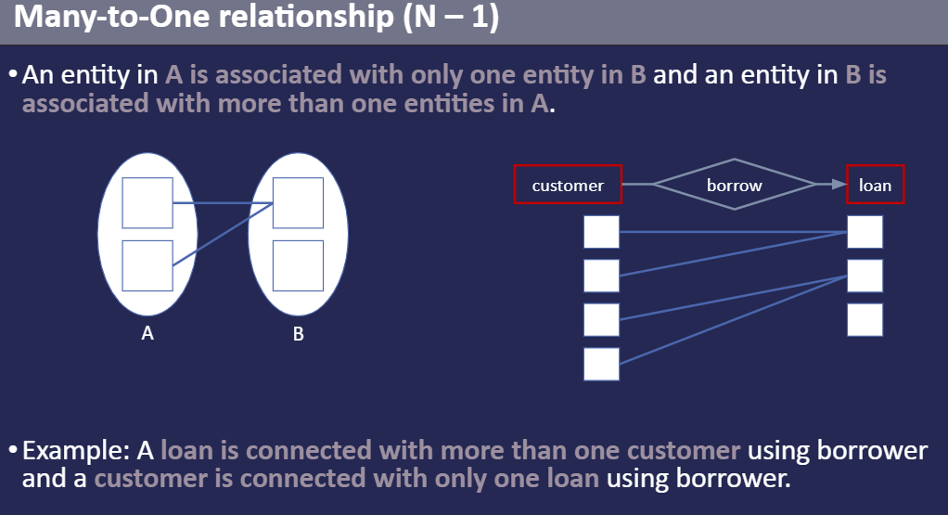

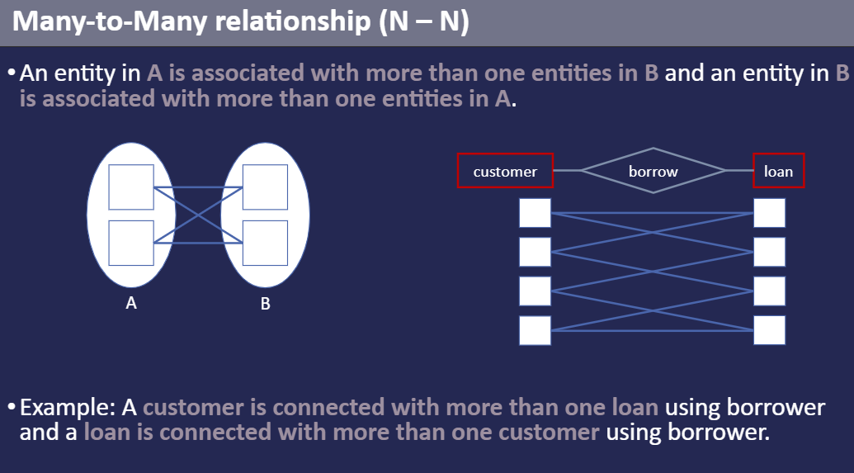

Library Management System ER Diagram
Entities and their Attributes –

Book Entity : It has authno, isbn number, title, edition, category, price. ISBN is the Primary Key for Book Entity.
Reader Entity : It has UserId, Email, address, phone no, name. Name is composite attribute of firstname and lastname. Phone no is multi valued attribute. UserId is the Primary Key for Readers entity.
Publisher Entity : It has PublisherId, Year of publication, name. PublisherID is the Primary Key.
Authentication System Entity : It has LoginId and password with LoginID as Primary Key.
Reports Entity : It has UserId, Reg_no, Book_no, Issue/Return date. Reg_no is the Primary Key of reports entity.
Staff Entity : It has name and staff_id with staff_id as Primary Key.
Reserve/Return Relationship Set : It has three attributes: Reserve date, Due date, Return date.

What is SQL (Structured Query Language)?
Structured Query Language, is a database computer language designed for managing data in relational database management systems (RDBMS), and originally based upon relational algebra and calculus. Its scope includes data insert, query, update and delete, schema creation and modification, and data access control. SQL was one of the first commercial languages for Edgar F. Codd‘s relational model.
SQL is a DSL (Data Sub Language), which is really a combination of two languages. These are the Data Definition Language (DDL) and the Data Manipulation Language (DML). Schema changes are part of the DDL, while data changes are part of the DML.

What is difference between data and information in DBMS?
Data is an individual unit that contains raw materials which do not carry any specific meaning. Information is a group of data that collectively carries a logical meaning. Data doesn't depend on information. Information depends on data

What is DBMS (Database Management System) ?
A Database Management System (DBMS) is a set of computer programs that controls the creation, maintenance, and the use of a database.
A database is a collection of information that is organized so that it can easily be accessed, managed, and updated.

What is an Attribute?
An attribute in a table is a named column or they are the set of important properties which describes the particular entity. An attribute may consist of name, roll number, age etc. Relations are used to hold information about the object.

What are Derived Attributes?
Derived attributes are those attributes which are based on and are derived from the attributes of another table or a relation.

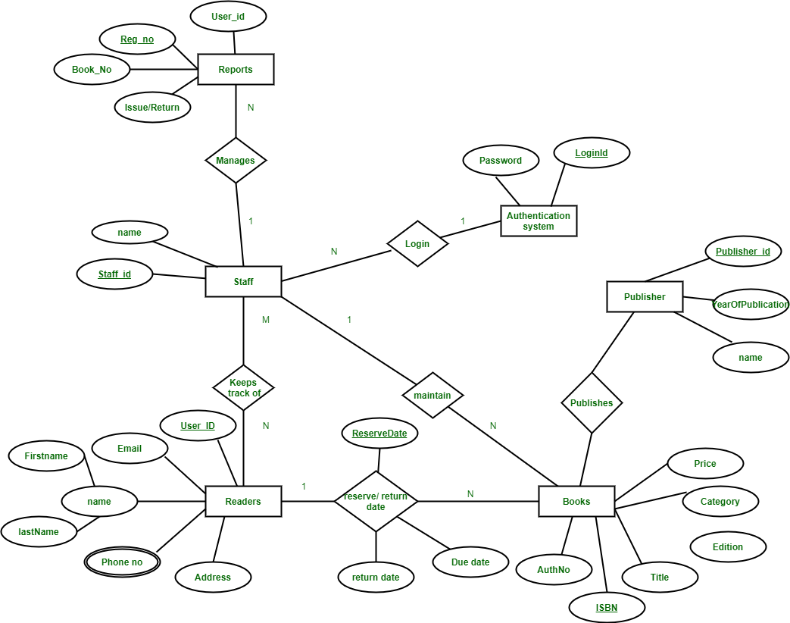

Hospital Management System ER Diagram
